Ospan Ramazan it2-2310, 38045

*HomeWorks:*

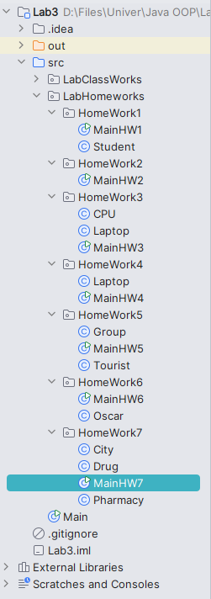

Work structure

Task1:

Create a class called **Student**, which has parameters and methods:

int id

String name String surname double gpa

Student() //default constructor

Student(int id, String name, String surname, double gpa)

String getData() // This method returns all data of student in one row in following format

**Example:** ID: 1, Student: Ilyas Zhuanyshev, GPA: 4.0

In a main class, you should create at least five objects of student, put it into array and print their all data in a row.

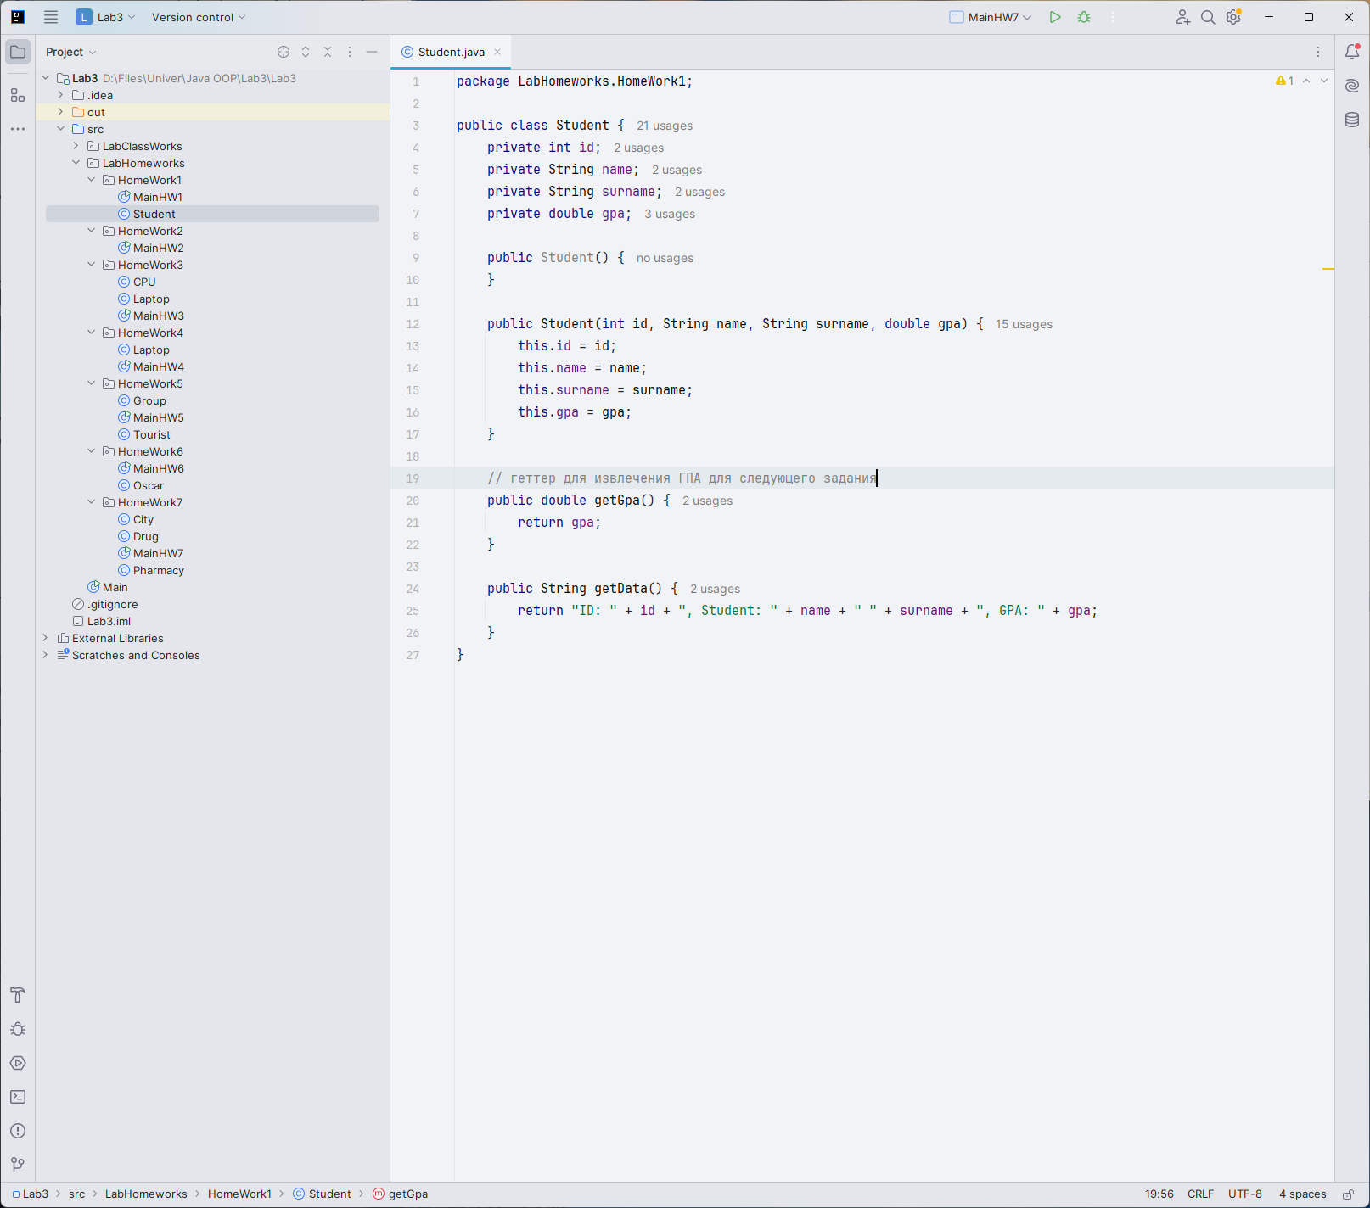

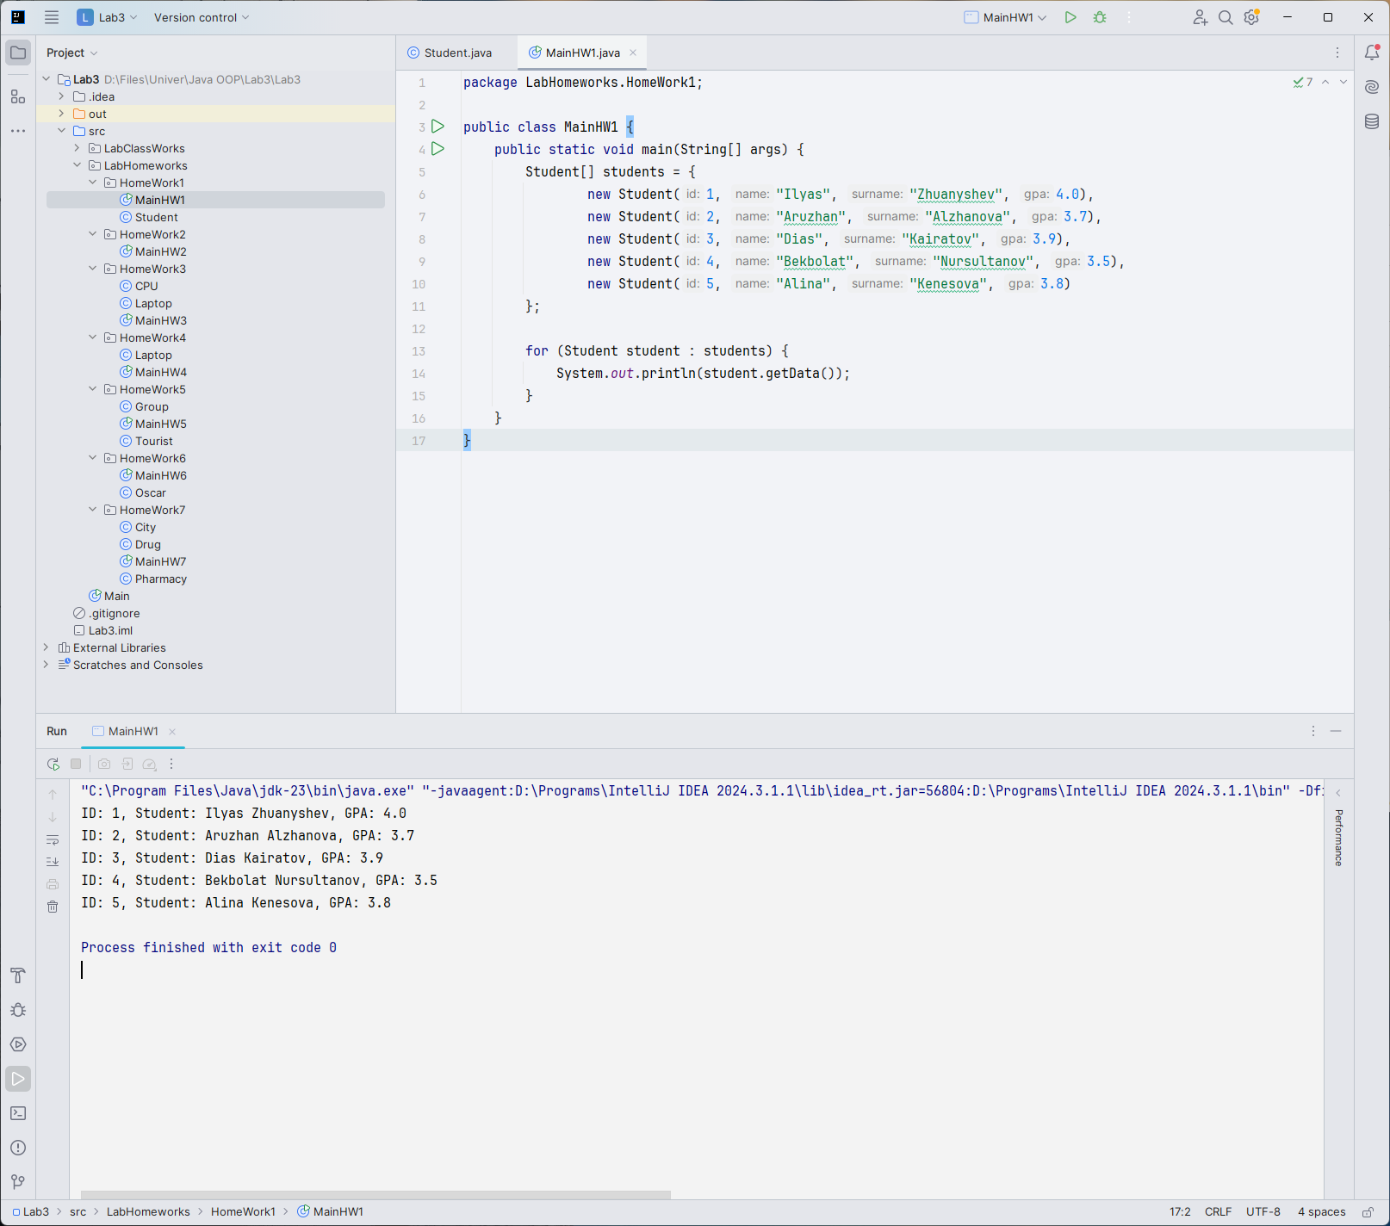

Task2:

Use previous Student class. Create at least 10 objects and put them into array.

You should sort array according to their gpa in descending order, and print their data. Use bubble sort

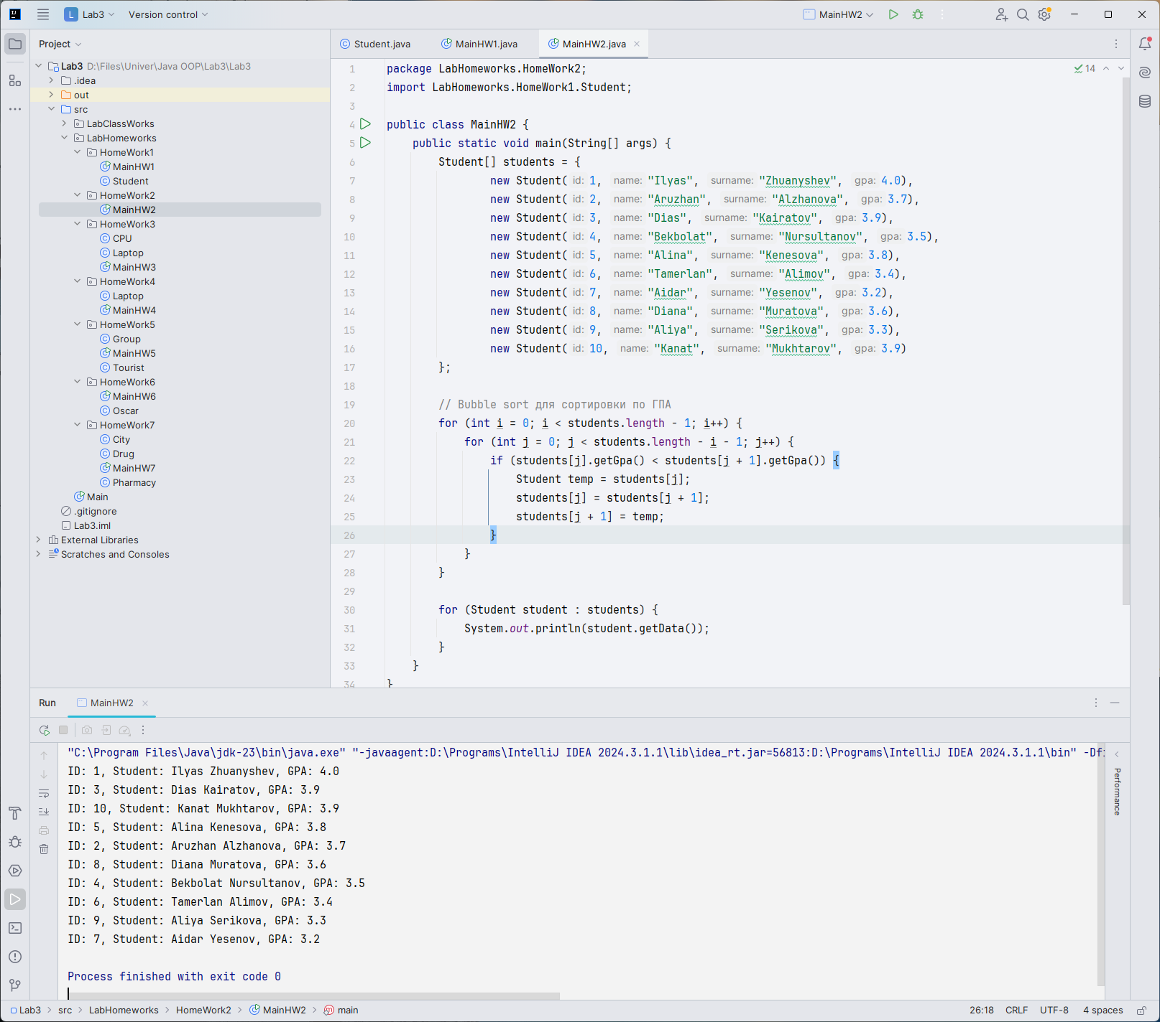

Task3:

Create a class called **CPU** with parameters:

String name; // Intel int RAM; // 4096 MB

double frequency; // 2.7 GHZ

Create default and parameterized constructors

String getCPUData(); // this method returns all fields of **CPU** class Create a class **Laptop** with parameters:

String name;

int HDDMemory; CPU processor;

Create default and parameterized constructors void printLaptopData();

This method prints laptop data, including **CPU** data. For **CPU** data, use getCPUData() method of **CPU**

object;

void execute();

This method prints, "Laptop is started and executing" if RAM of its CPU is greater than 4096 and frequency is greater than 2.5 GHZ, otherwise "Cannot start computer".

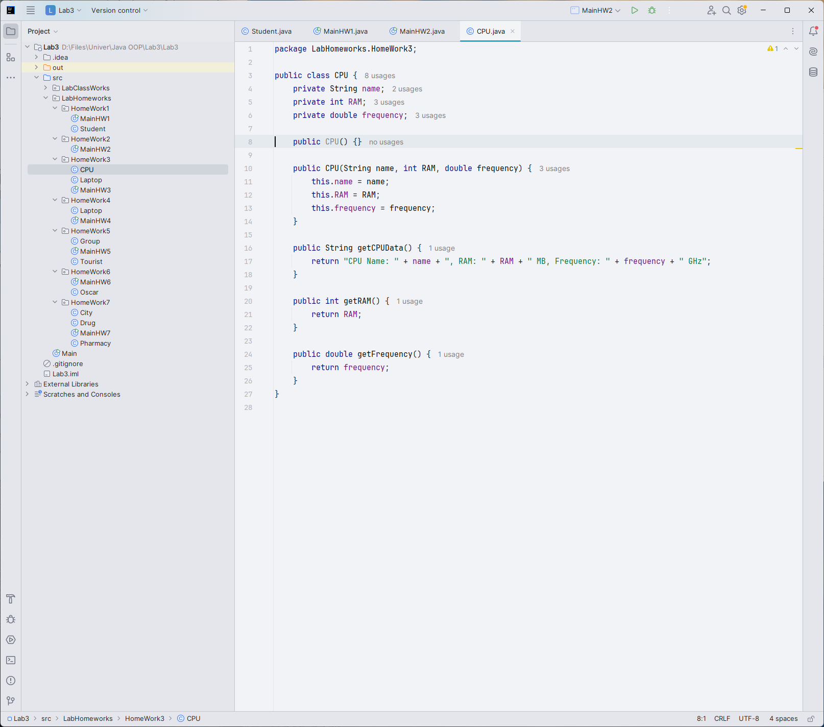

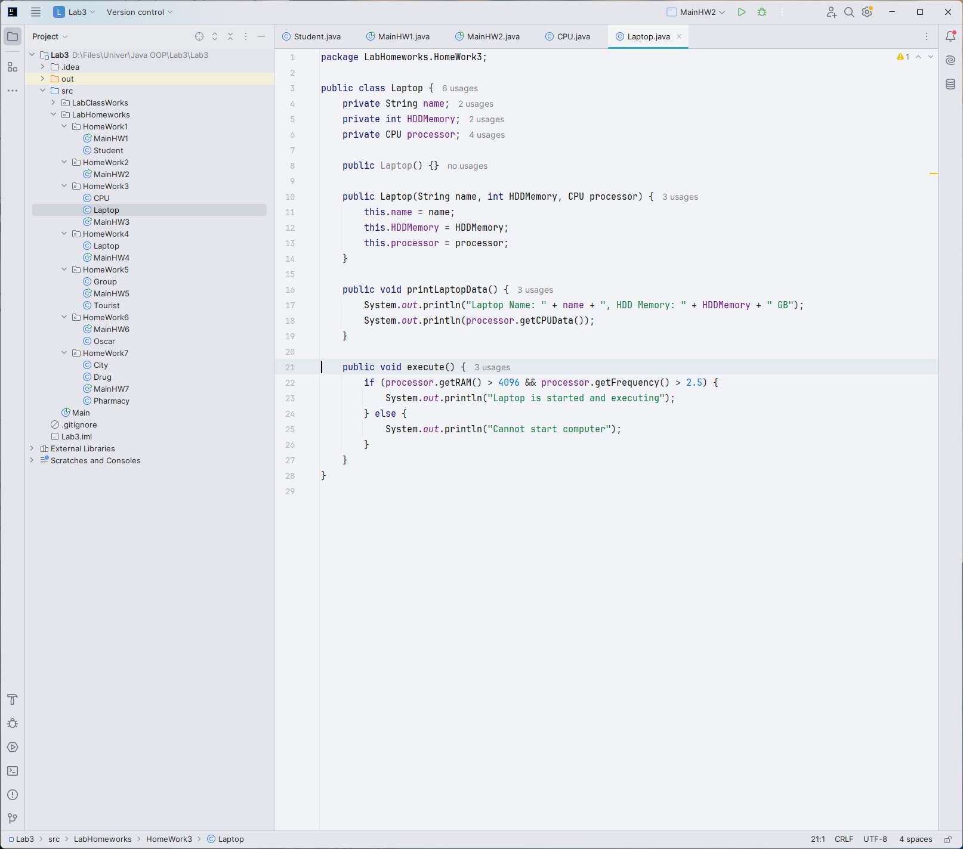

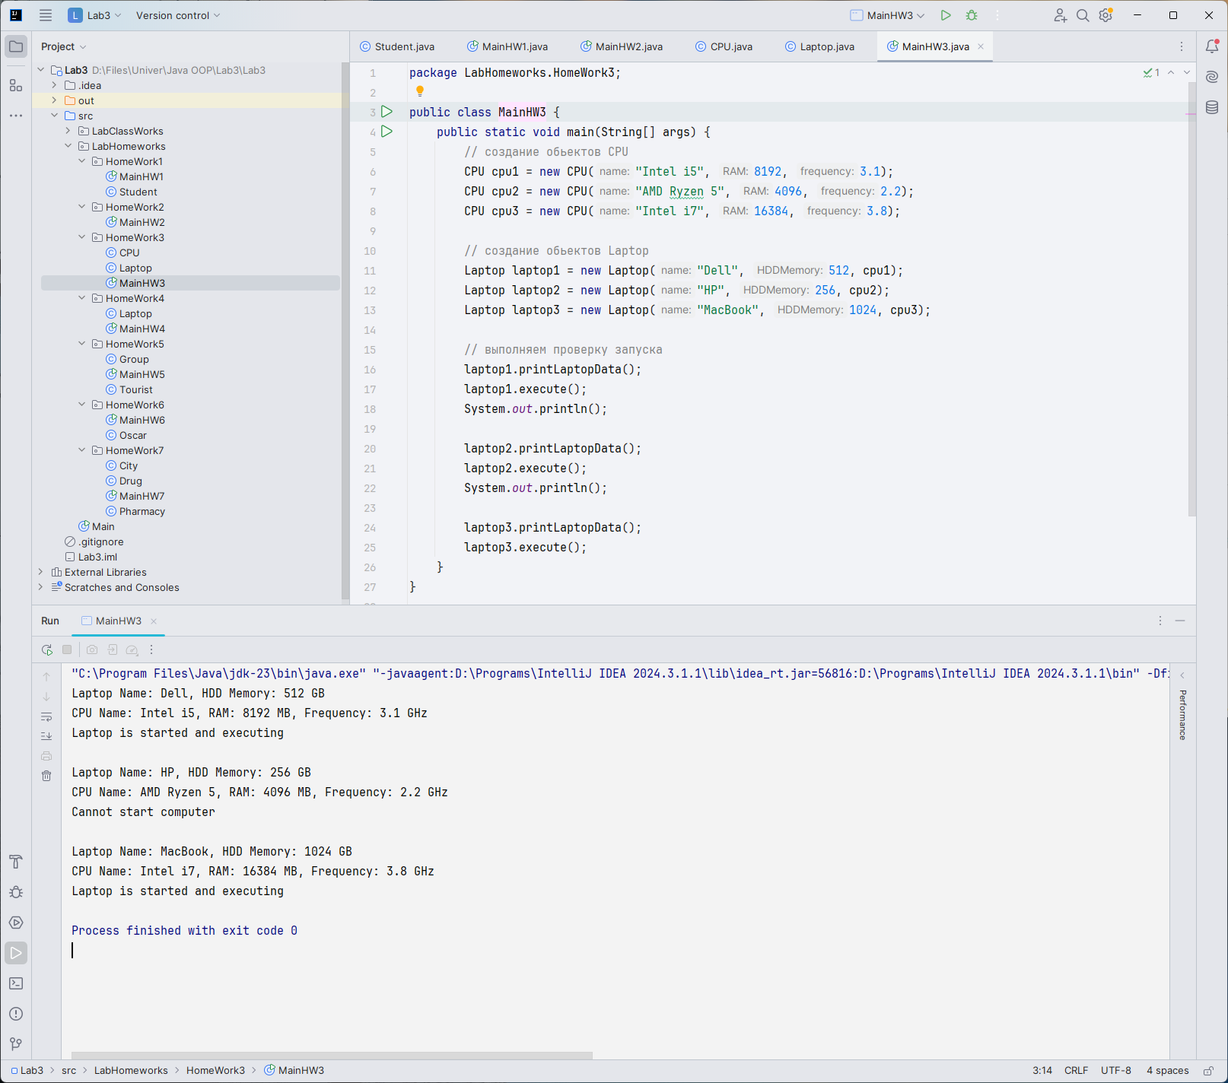

Task4:

Create a class Laptop with rows:

String name;

int price;

int generation_of_CPU;/// 8,9,10

string ssd;//yes or no

You need to calculate the new price of laptop regarding to their characteristics. Add +10%, 15% or 20% according to their generation of CPU for 7,8,9 respectively. Also, if laptop has a ssd you need to add 15% to the price.

Input:

3

Macbook 540000 10 YES

Lenovo 100000 9 NO

Asus 145000 8 YES

Output:

Macbook 729000

Lenovo 115000

Asus 181250

(Explantion for Asus – 145000 + 14500(10% of 145000) + 21750(15% of 145000))

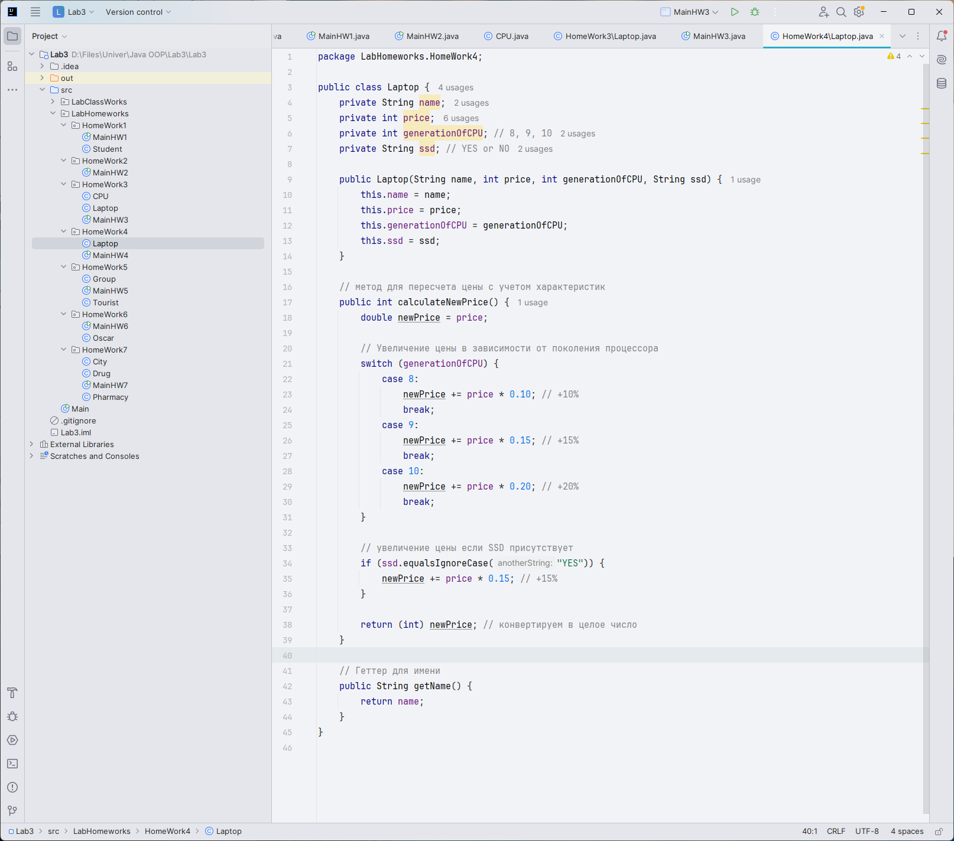

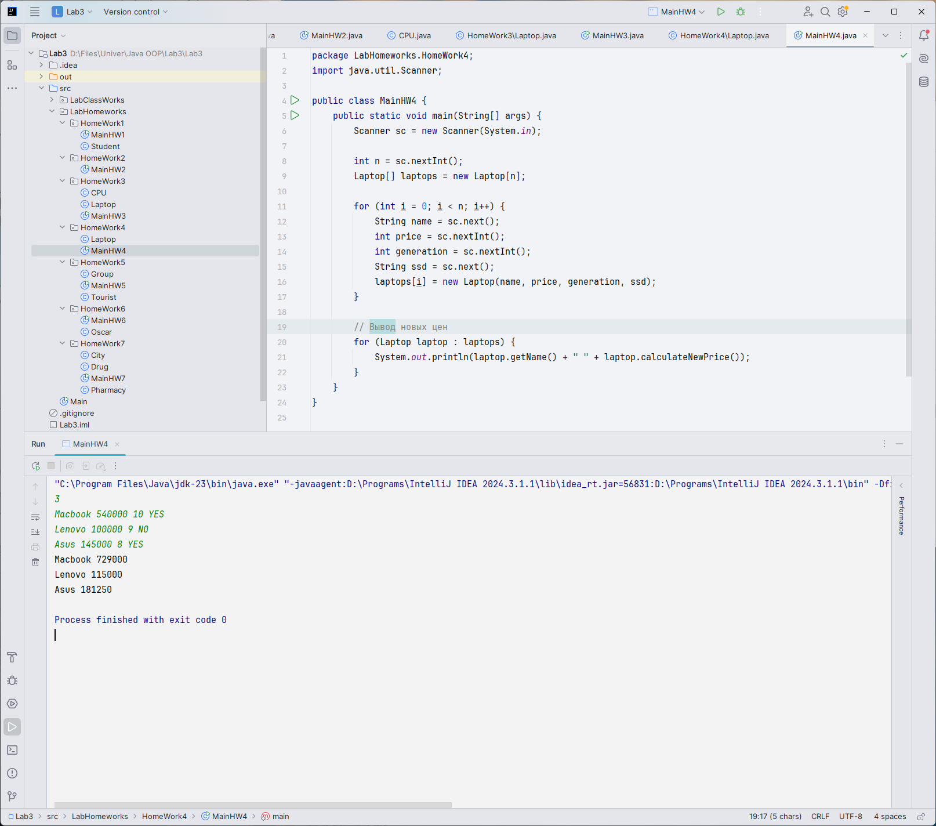

Task 5:

Create a class called Tourist with parameters:

String name;

Int money;

string access;

Create a class Group with parameters:

String name;

Int countOfTourist

Tourist* tourist;

Tourists want to go to expedition. But some these have no access(maybe according to age, no matter) and the cost of expedition is 20000 tg. You need to check whether they can go to expedition or not(If total sum of their money lower than 20000 tg they can’t go)

Print “YES” if group can go to expedition and “NO” otherwise

Input:

2

SIS-1804 4

Kazybek 5000 YES

Aruzhan 12000 YES

Bekbolat 7000 NO

Alina 9500 YES

SIS-1811 3

Dias 9000 YES

Tamerlan 13000 NO

Amir 10000 YES

Output:

SIS-1804 - YES

SIS-1811 - NO

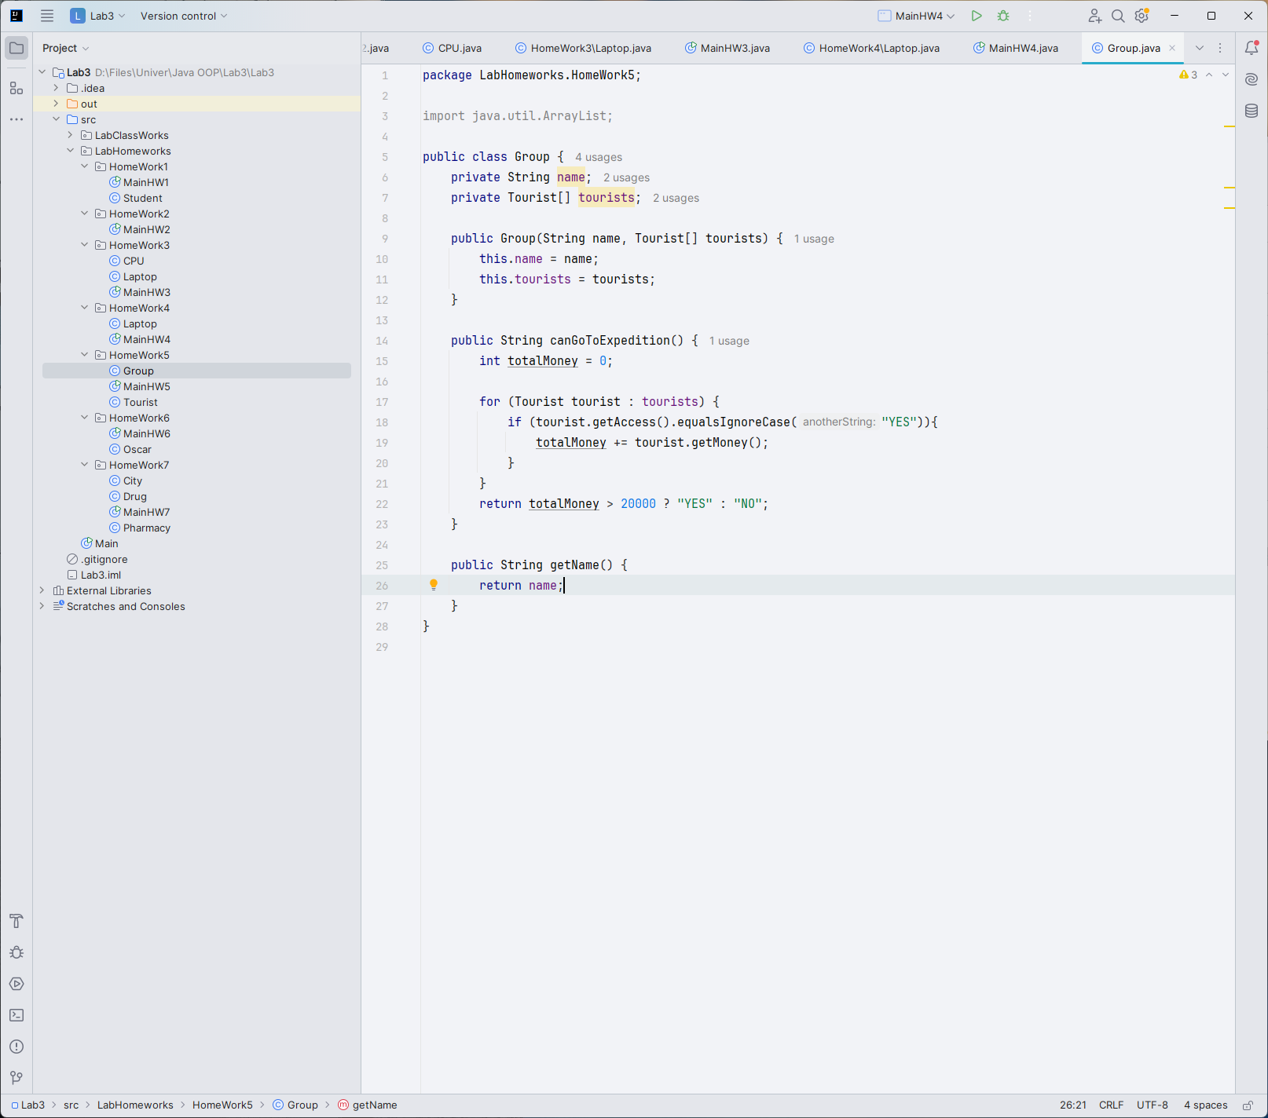

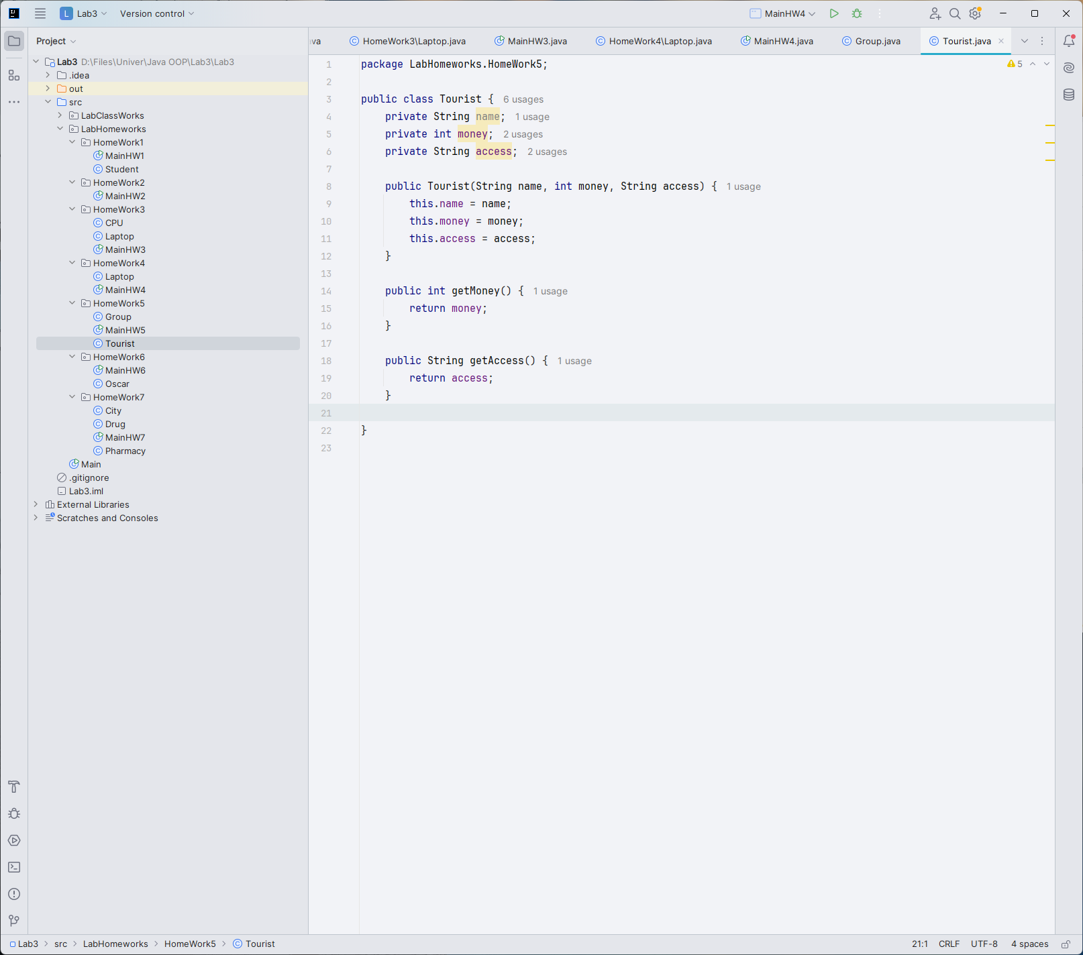

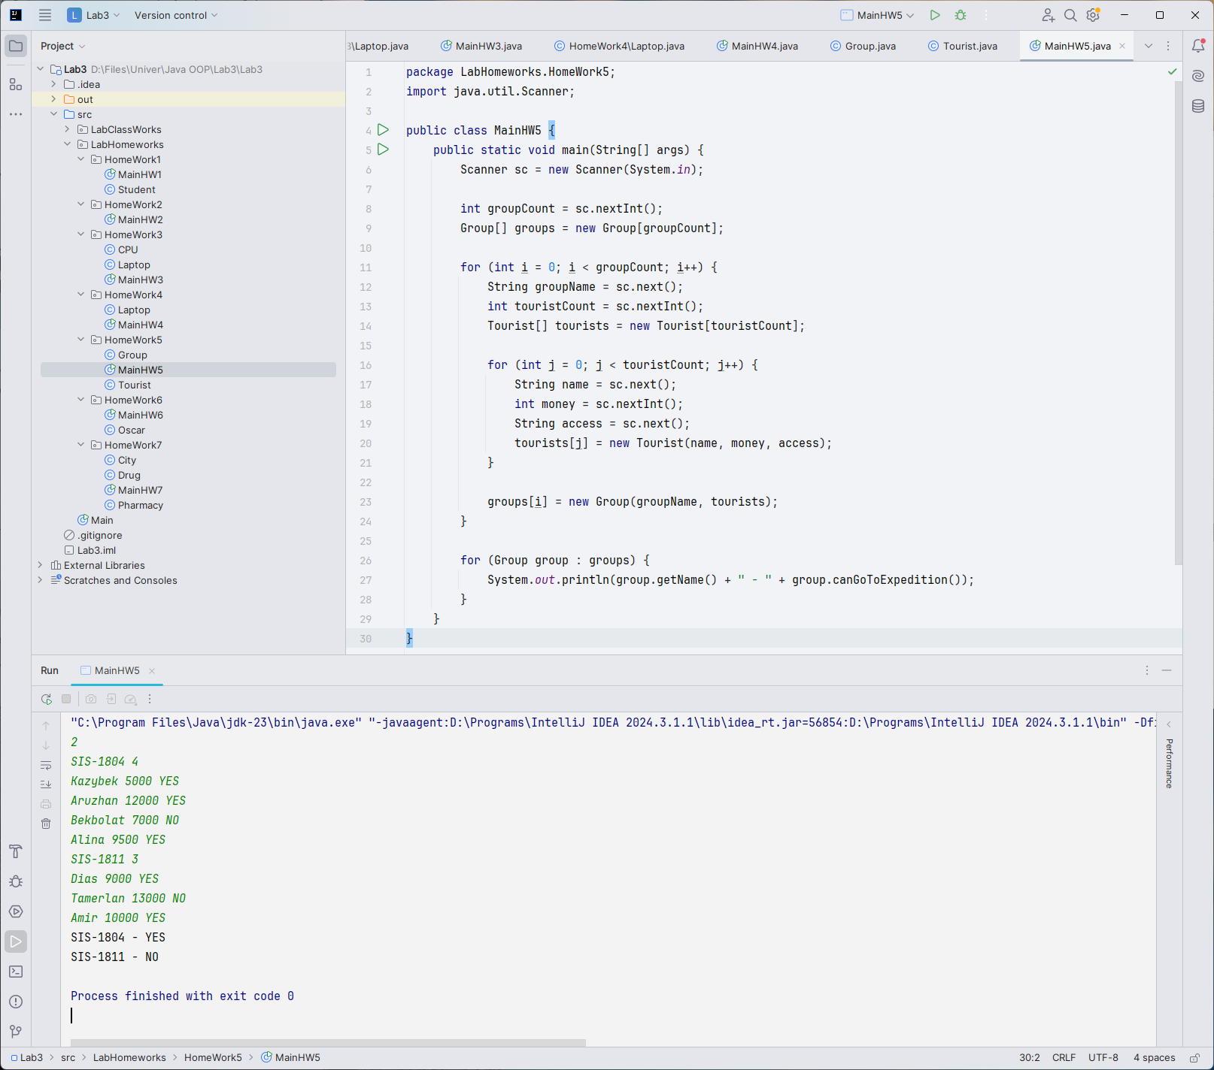

Task 6:

Create class:

class Oscar which has:

- name//name of an actor or actress (string)

- surname

- movies(int) //number of movies

- rating(double) //average rating among movies

Your task is to show nominees from the participants' list sorted in descending order according to rating.

If ratings are equal sort by number of casted movies(actors, who participated more often has a high rating).

Input:

n (how many actors/actress) [2 <= n <= 10]

n-times:

name

surname

movies

avg_rating

Output:

All sorted Oscar award nominees.

Example:

Input:

6

Brad Pitt 40 7.0

Kate Moss 31 6.9

Gal Gadot 5 7.1

Johnny Depp 50 7.8

Leonardo DiCaprio 35 7.9

Penelope Cruz 27 7.8

Output:

Leonardo DiCaprio 35 7.9

Johnny Depp 50 7.8

Penelope Cruz 27 7.8

Gal Gadot 5 7.1

Brad Pitt 40 7.0

Kate Moss 31 6.9

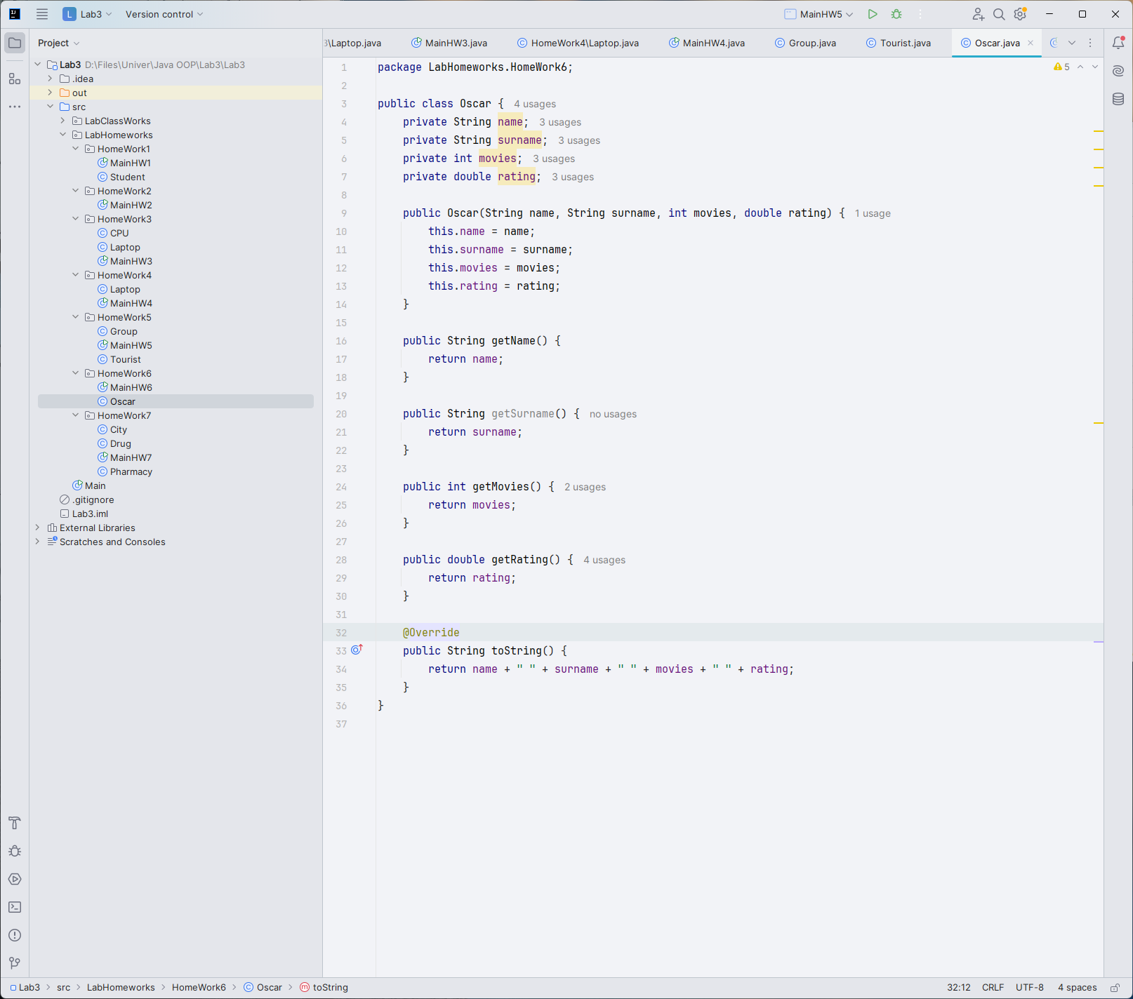

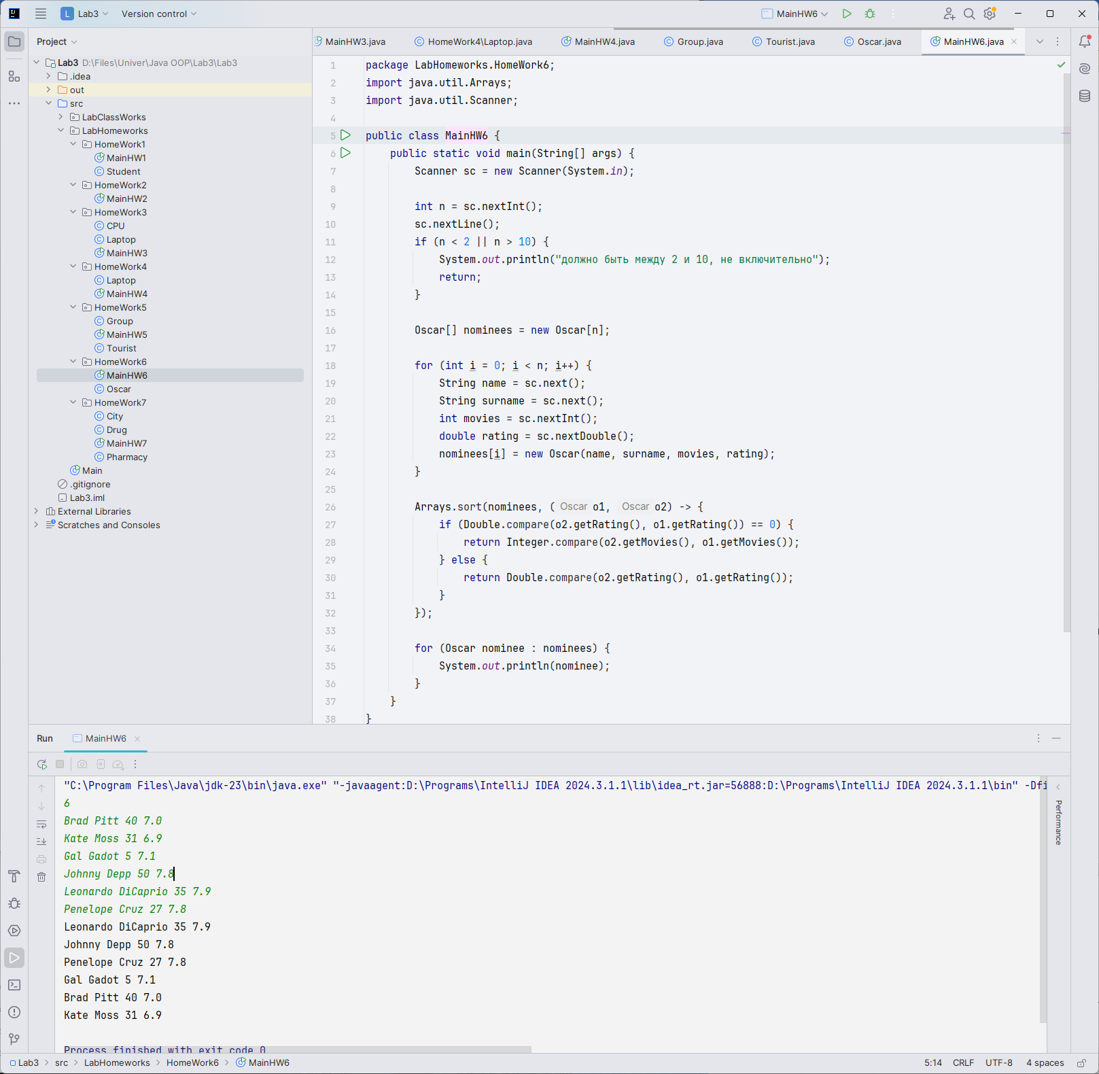

Task 7:

Create a class Drug with parameters:

string name;

Int price;

string outOfDate;//”YES” если лекарство просрочено

Create a class Pharmacy with parameters:

string name;

int countOfDrugs;

Drug*

Create a class City with parameters:

string name;

int countOfPharmacy;

Pharmacy* pharmacy;

**Print the most expensive drug in each pharmacy (80%) and each City (100%).**

Input:

2

ALMATY 2

KZPharma 3

Adderall 2000 YES

Clonazepam 3200 NO

Lexapro 950 YES

Evalar 2

Xanax 5600 NO

Pantoprazole 1800 YES

ASTANA 2

EuroPharma 4

Gabapentin 7400 NO

Cymbalta 1600 YES

Tramadol 450 YES

Azithromycin 780 NO

Health 2

Ritalin 1200 YES

Methadone 9800 YES

Output:

City: ALMATY

The most expensive drug in KZPharma is Clonazepam

The most expensive drug in Evalar is Xanax

THE MOST EXPENSIVE DRUG IN ALMATY: Xanax

ASTANA 2

The most expensive drug in EuroPharma is Gabapentin

The most expensive drug in Health is Methadone

THE MOST EXPENSIVE DRUG IN ASTANA: Methadone

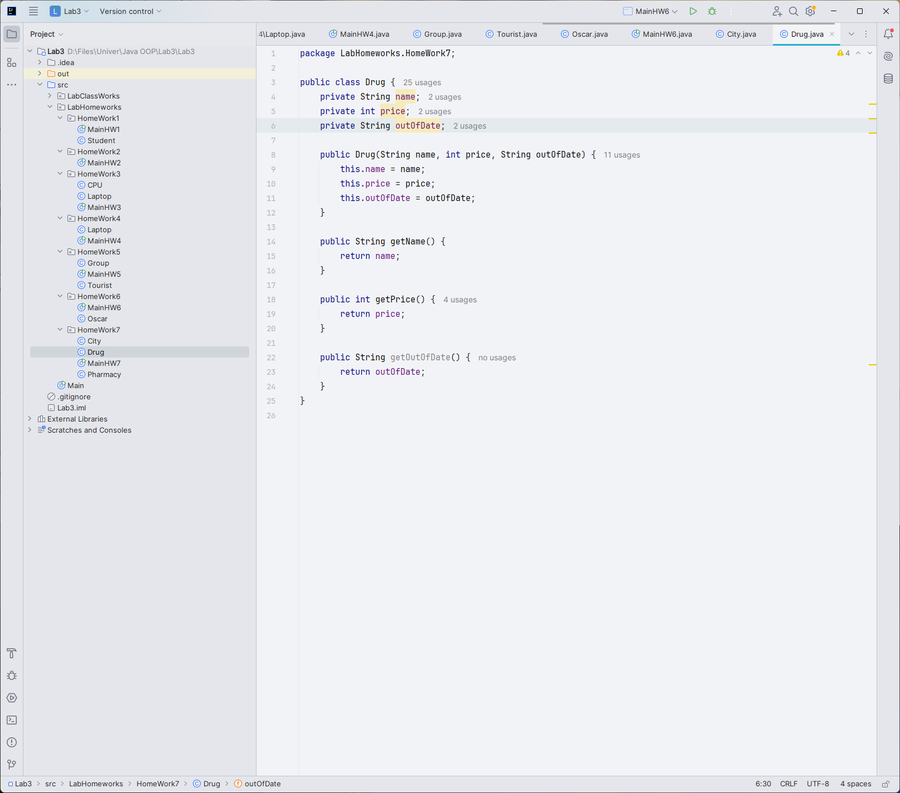

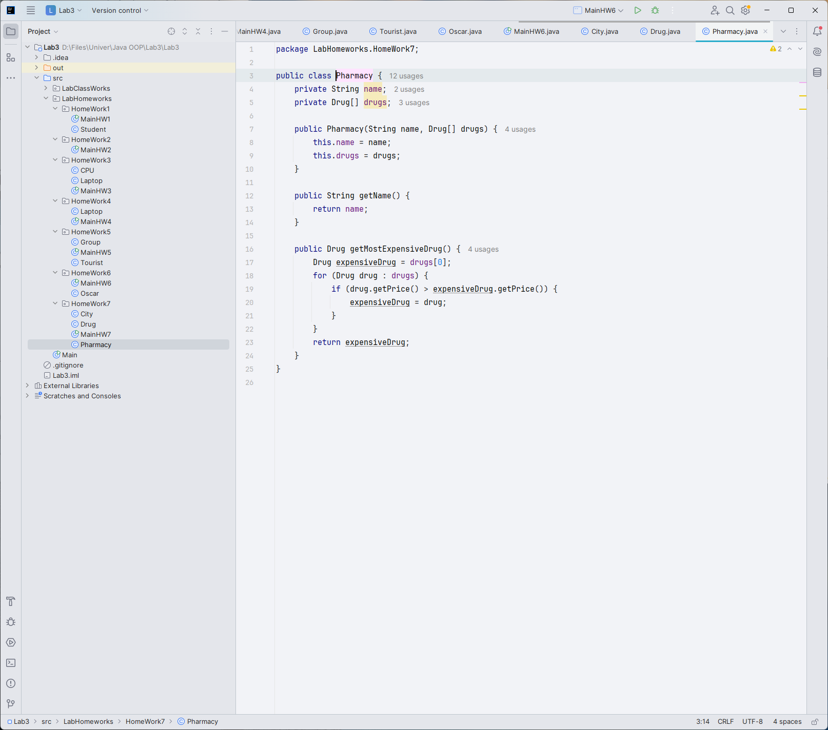

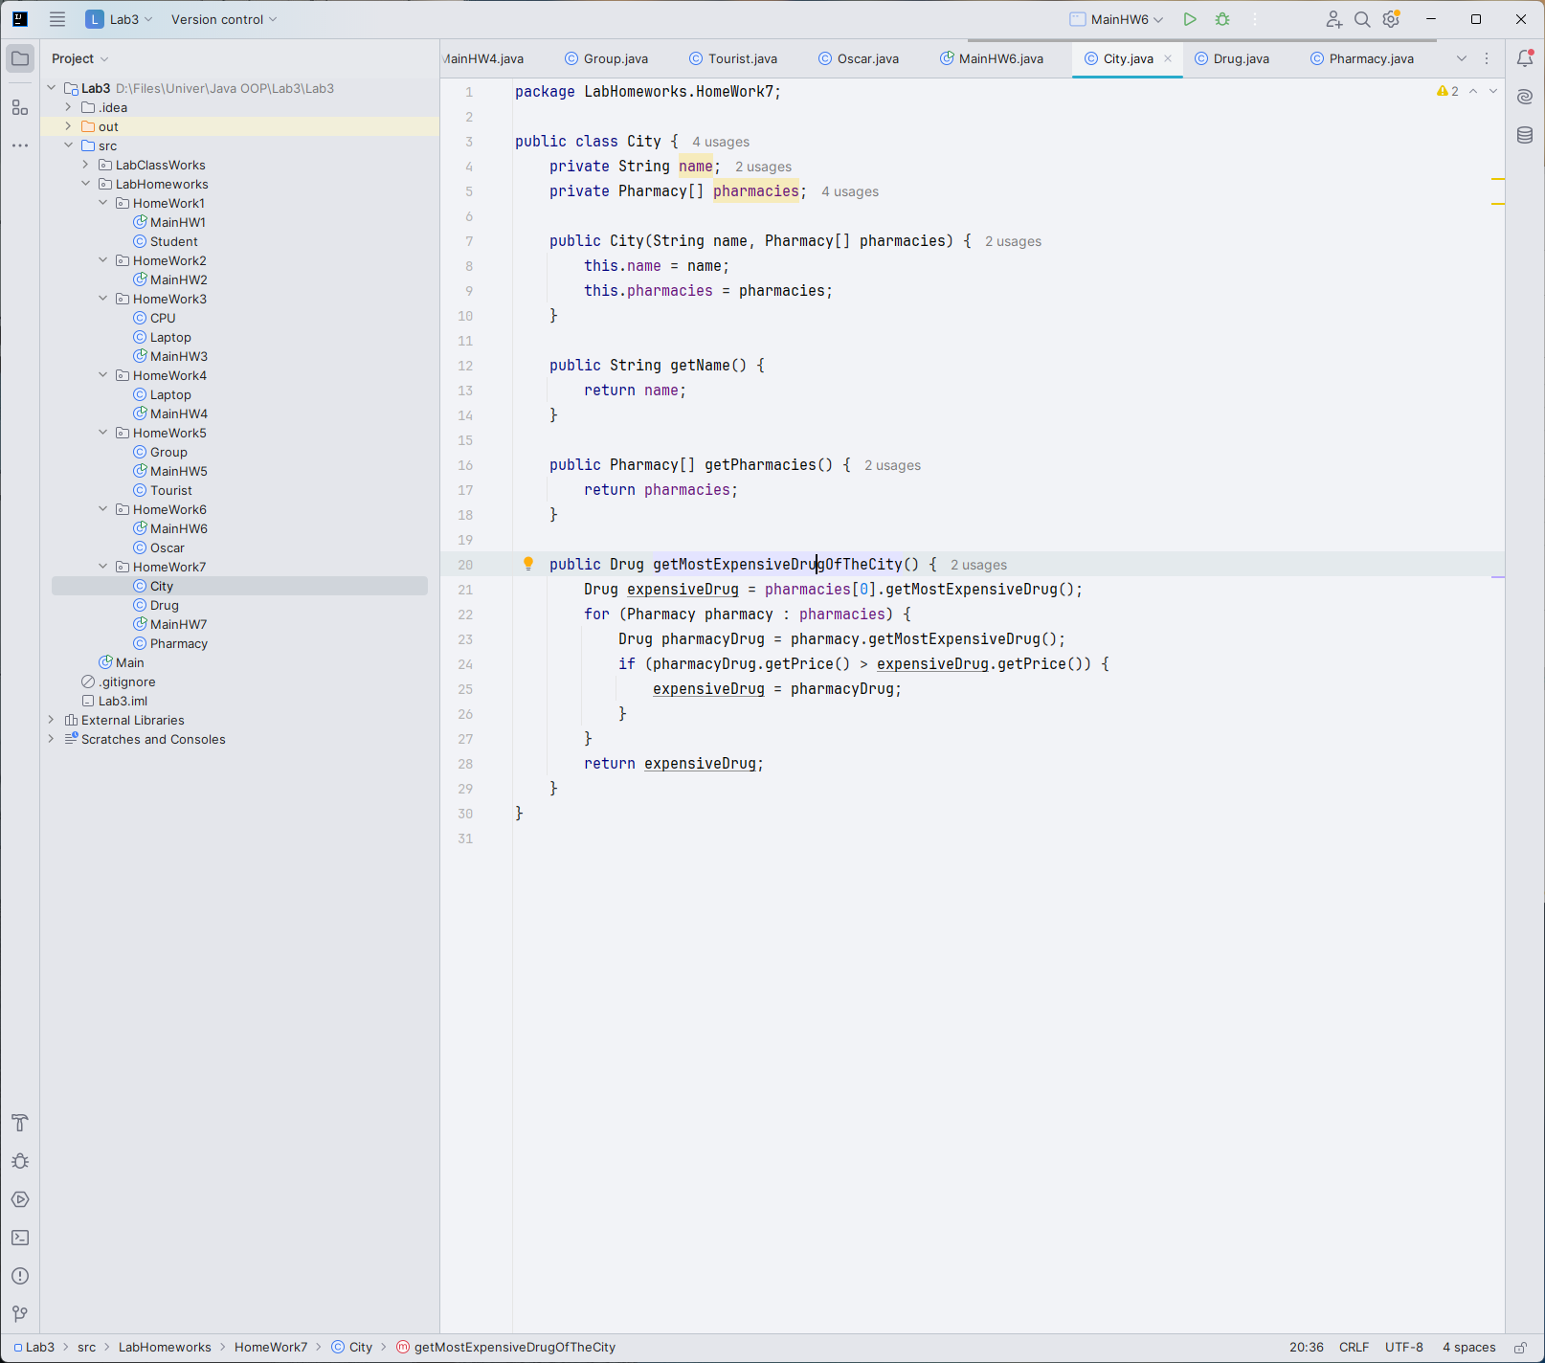

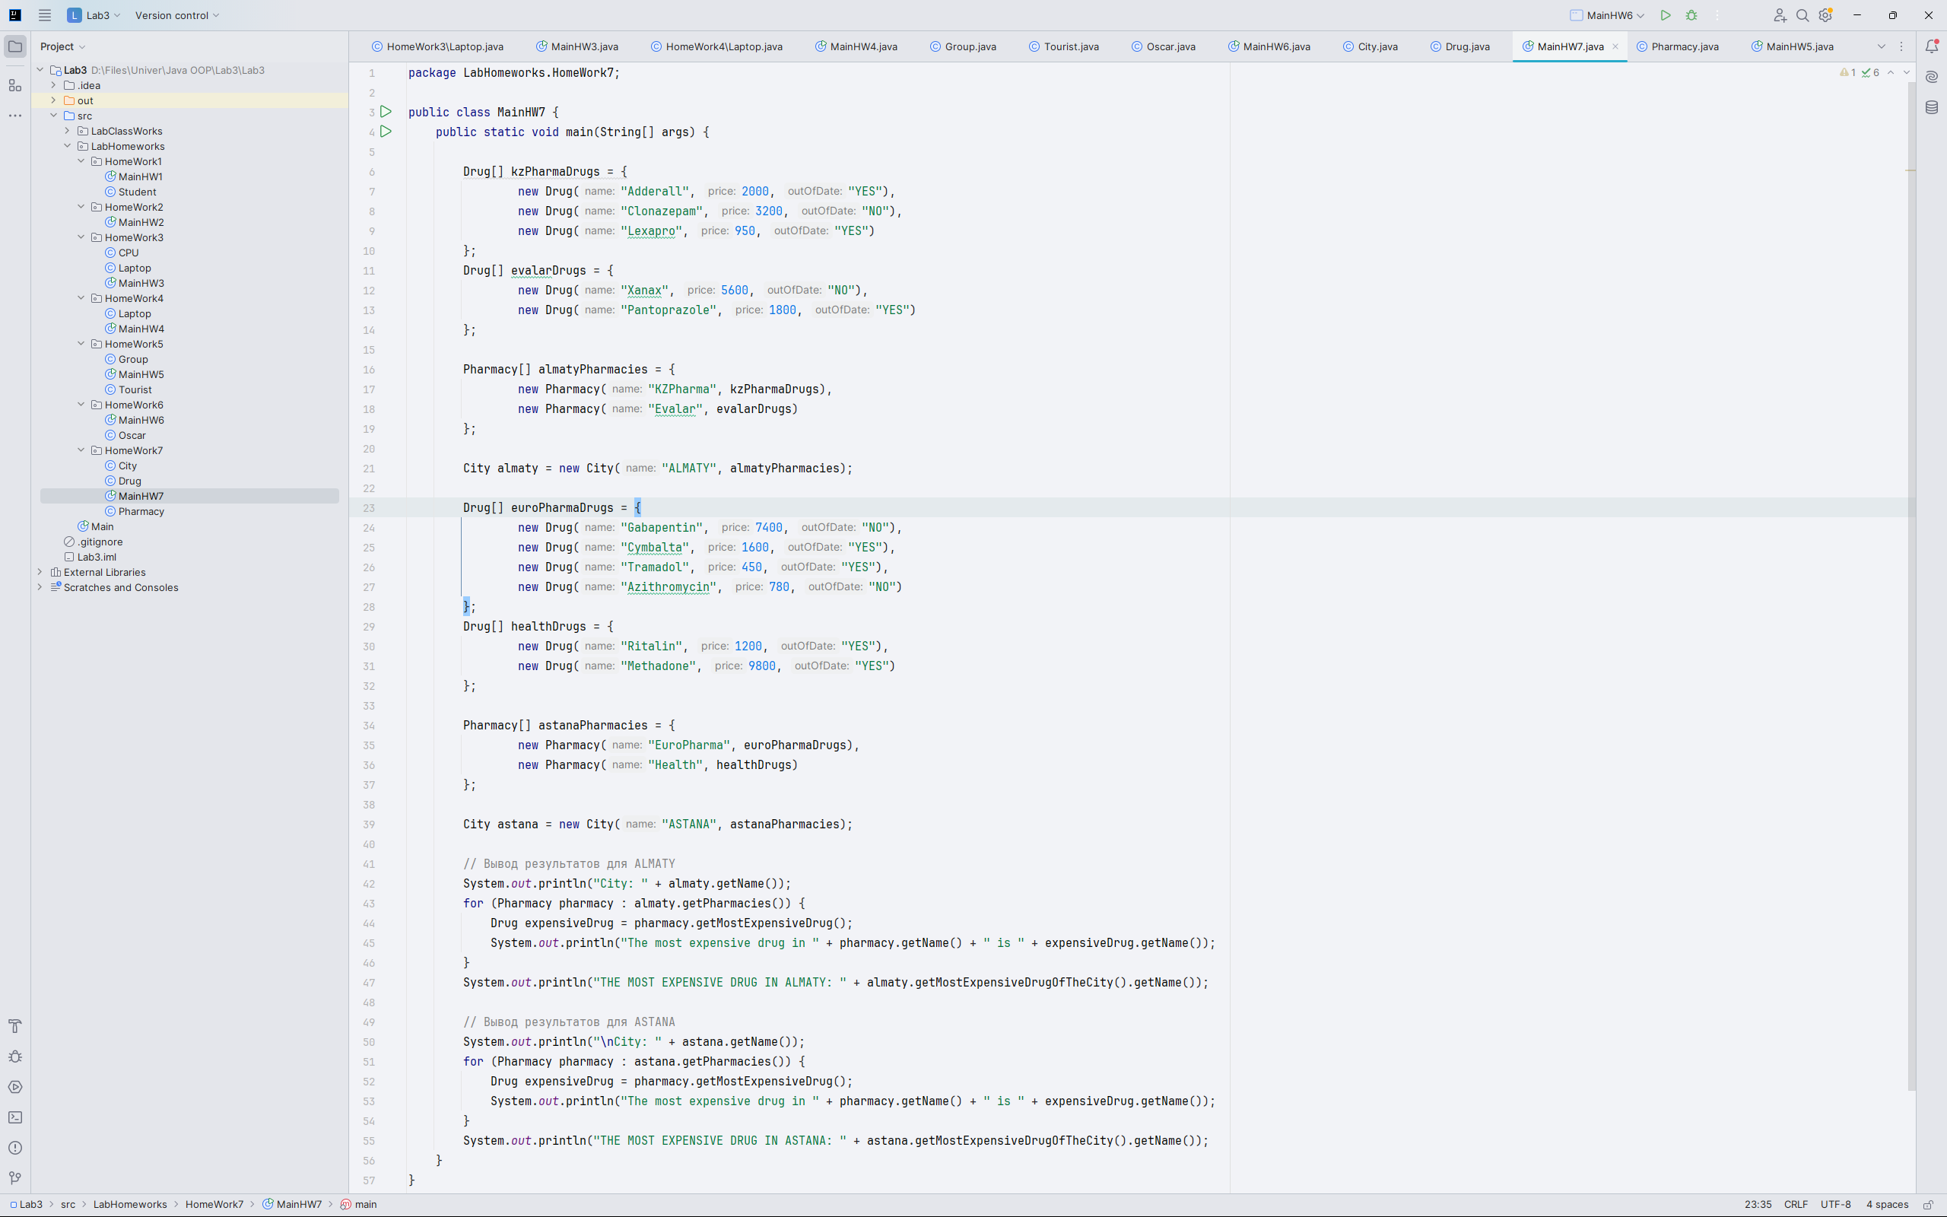

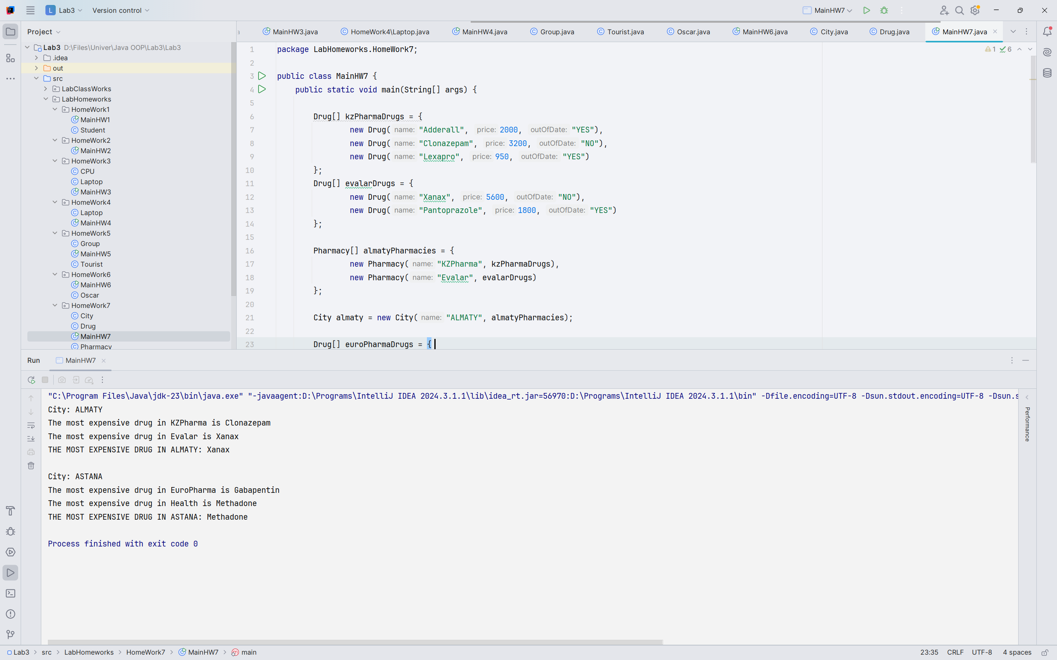

Code sources:

